COOKING IN CENTRAL
P. O. Box 78333
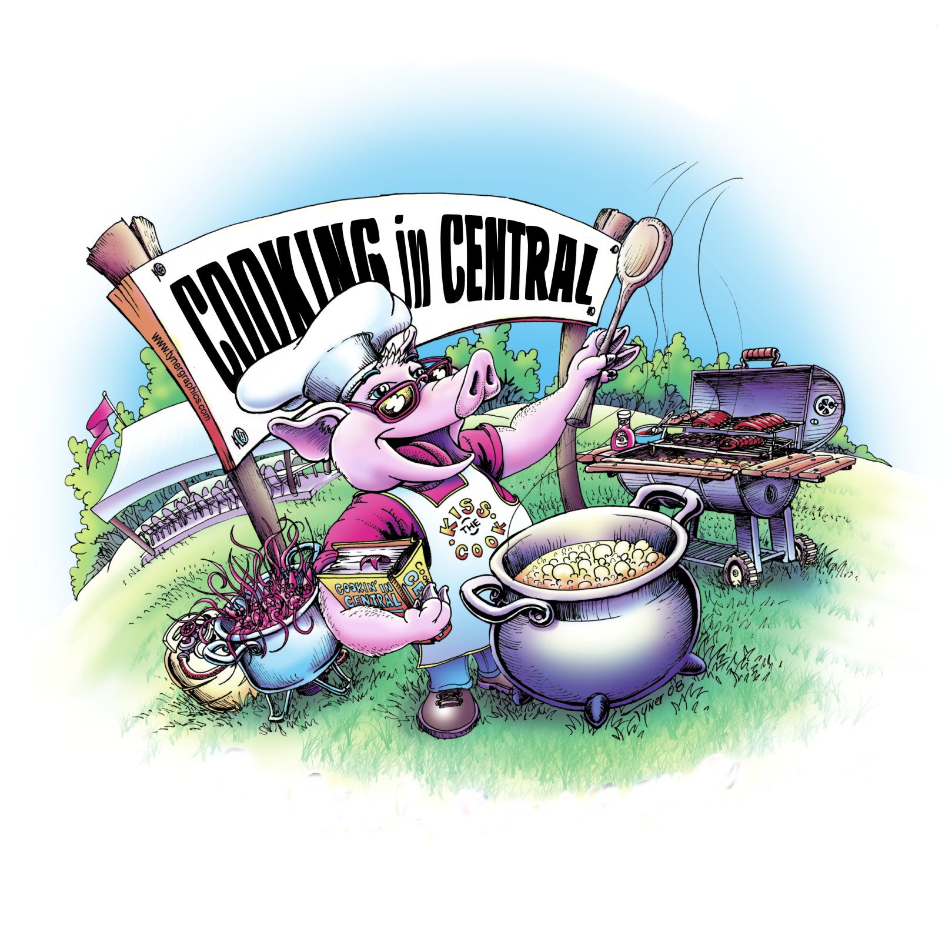
Central, LA 70837

Email: info@cookingincentral.com
Website: www.cookingincentral.com

AMAZING PLACE
USAGE REQUEST FORM & FEES

GENERAL INFORMATION
Organization Requesting Use:

Authorized Representative’s Name:

Organization Address:

(Street or P.O. Box) (City) (State) (Zip)
Phone/Cell: |  |  | Email Address:
Activity/Event Description:

Estimated # of Participants and Attendees: |  |  |  | Is this is a catered event: |  | YES☐ |  | NO ☐ |  | If yes, what is the company’s name who is providing the food:
 |  |  |  |  |  |  |  |  |  | (provide their additional insured certificate listing Cooking in Central)
Start Date: |  | End Date: |  |  | Day of Week: |  |  |  | Start Time: |  |  | End Time:

Fees Structure

Basic Rental - $1500.00 per day.
Non-profits outside the city limits of the City of Central are at the Basic Rental rate - $1500.00 per day.
Non-profit Civic, Religious or School Groups inside city limits of the City of Central - $450.00 per day.
All non-profits must supply a copy of their IRS issued 501c letter with the application.

Rental Fee is due with the Application.

Should the lessee terminate this agreement, a refund shall be provided less the costs incurred by Cooking in Central.

Amazing Place Use Policy
Cooking in Central (sometimes hereinafter referred to as “CIC”) established The Amazing Place to provide a facility and grounds to hold outdoor events for our community to enjoy. It is the responsibility of Cooking in Central to provide oversight of The Amazing Place property, to ensure its proper use, maintenance, safety and access. The following policies have been developed to govern activities conducted at The Amazing Place.

A. CIC’s use of its own facilities will take precedence over any outside requests.

B. No commitment for continuous use of the facilities will be made between parties.

C. There is a charge for the general use of The Amazing Place. The fees shall be as stated in the written agreement between CIC and lessee. Lessee agrees to the fees set forth by CIC.

D. A Certificate of Insurance(s), listing Cooking in Central as additional insured, with the minimum of these coverage amounts: $1,000,000 each occurrence, $1,000,000 Personal & ADV injury and $2,000,000 General Aggregate, shall be provided to prior to the use of the Amazing Place.

E. The Amazing Place closes at 10:00pm. No activities may be held after 10 p.m. without prior permission from CIC.

F. Pets must always be leashed, and droppings removed.

G. Riding of horses or the grazing of any livestock on park property is prohibited.

H. Alcoholic beverages may be brought, sold and consumed on The Amazing Place property subject to compliance with all state and local statutes, regulations, and ordinances including, but not limited to, minimum drinking age and permitting requirements. If alcohol is being supplied or sold proof of insurance and any required state and/or local permits must be provided to CIC prior to lessee’s usage of the property.

I. Explosives of any type are prohibited at The Amazing Place.

J. Fireworks of any type are prohibited at The Amazing Place without proper permit.

K. Amplified music, sound systems and voice amplification devices are permitted, but at no time can music interfere with or be in violation of any applicable ordinances.

L. Use of fire is prohibited except in grills. No cooking is allowed under the pavilion. All charcoal from grills, grease from fryers, and water with added chemicals or seasonings (such as from seafood boils) must be removed from the property by lessee prior to the end time of the rental agreement. Dumping of charcoal, grease or impure water onto The Amazing Place grounds is prohibited.

M. Grounds and Facilities must be kept clean by removing all trash and litter from The Amazing Place property. For safety purposes glass containers are prohibited.

N. No property is to be moved or modified and will be left in the same or better condition.

O. All vehicles of any type or size must be operated by a licensed driver and vehicles must stay on driveways, roadways and in designated parking spaces. Leese is responsible for providing parking supervision on the premises as illustrated on the attached map.

P. Use of inflatables is permitted with proper documentation. (Provider's insurance will be required.) Inflatables are required to have anchors. If stakes are used, all stakes must be removed.

Q. The provision of Security Personnel is required and is solely the responsibility of the lessee.

R. Failure to comply with all provisions of this Use Policy may result in immediate expulsion from park property.
If you have any emergency contact 911.
CPD 225-367-1254 or EBRSO 225-389-5177.

I accept and agree to abide by the terms of the Amazing Place Use Policy and agree to the fees.

____________________________ _________________
Signature of Lessee Date

